High-Level Design

Campus Placement Prediction

**Abstract**

The project is about building a system that can predict placement status of students studying in various institutions. By analysing past student records according to placement status. Educational institutions kept records of their students to forecast future placement status. Yearly admission varies proportionately with the placement that it provide to it’s students. That’s why every institution is looking forward to strengthen its placement cell. This will always be helpful for both the students, as well as the institution.

**1. Introduction**

**1.1 Why these High-Level Design Documents?**

The purpose of this High-Level Design (HLD) Documents is to add necessary details to the current project description to represent a suitable for coding. This document is also intended to help detect contradictions before coding. And can be used as a reference manual for how the modules interact at a high level.

The HLD will be :

* Present all of the design aspects and define them in detail.
* Describe the user interface being implemented.
* Describe the needed Python libraries for the coding.
* Describe the performance requirements.
* Include design features and the architecture of the project.
* List and describe the non-functional attributes like:
  + Security
  + Reliability
  + Maintainability
  + Portability
  + Reusability
  + Application Compatibility
  + Resource Utilization
  + Serviceability

**1.2 Scope**

The HLD documentation presents the structure of the system, such as the database architecture, application architecture(layers), application flow (Navigation), and technology architecture, The HLD uses non-technical and mildly-technical terms which should be understandable to the administrators of the system

**1.3 Definition**

|  |  |
| --- | --- |
| TERM | Description |
| DB | A database is **information that is set up for easy access, management and updating**. Computer databases typically store aggregations of data records or  files that contain information, such as sales transactions, customer data,  financials and product information. |
| ML | Machine Learning |
| API or APIs | APIs are mechanisms that enable two software components to communicate with each other using a set of definitions and protocols. |

**2. General Description**

**2.1 Product Perspective**

The Campus Placement Prediction is an ML-based Web Application that Is able to predict placement status of students based past records. It will tell us whether the students are placed on not placed.

**2.2 Problem Statement**

Tu builds a system the will be able to take information about a student and can predict if he will be placed or not placed. We have to build an application and that will be able to produce results.

**2.3 Proposed Solution**

We will perform EDA to find the important relation between different attributes and will use a machine-learning algorithm to predict the placement status. The client will be filled the required feature as input and will get results through the web application.

**2.5 Data Requirements**

The data required for building the project is already available on the dashboard. The Campus Placement Prediction data is recorded many students information along with educational career description

This data set consists of Placement data of students in our campus. It includes secondary and higher secondary school percentage and specialization. It also includes degree specialization, type and Work experience and salary offers to the placed students

Source: <https://www.kaggle.com/benroshan/factors-affecting-campus-placement> or

<https://www.kaggle.com/c/ml-with-python-course-project/data>

Attribute Information: sl_no Serial Number

gender Gender- Male='M',Female='F'(male=0, female=1)

ssc_p Secondary Education percentage- 10th Grade

ssc_b Board of Education- Central/ Others

hsc_p Higher Secondary Education percentage- 12th Grade

hsc_b Board of Education- Central/ Others

hsc_s Specialization in Higher Secondary Education

degree_p Degree Percentage

degree_t Under Graduation(Degree type)- Field of degree education

workex Work Experience

etest_p Employability test percentage ( conducted by college)

specialisation Post Graduation(MBA)- Specialization

mba_p MBA percentage

status Status of placement- Placed/Not placed

salary Salary offered by corporate to candidates

**2.6 Tool Used**

The programming language is Python that is used here, also we will use some other python-based libraries like for ml we will use Scikit-Learn library, for data manipulation we will use pandas, for numerical computation Numpy, for custom APIs creation we use frameworks.

**2.7 Constraints**

The System should be user-friendly, the user should get all proper messages while using the web app. He/she also should get a proper error message if he/she has done something wrong On the web-app page. All the errors and results should be delivered in the easiest possible way and all the buttons are going to insert on the webpage should be labeled properly, so the user did not get confused to use the system.

**2.8 Assumptions**

The main objective is to implement a system that will produce the placement status of students and help them to choose the better college for them.

**3. Design Details**

**3.1 Process Flow**

We will be using following process flow for this project. The process will be based on modular coding i.e. use of oops concepts to build the entire project from start to end.

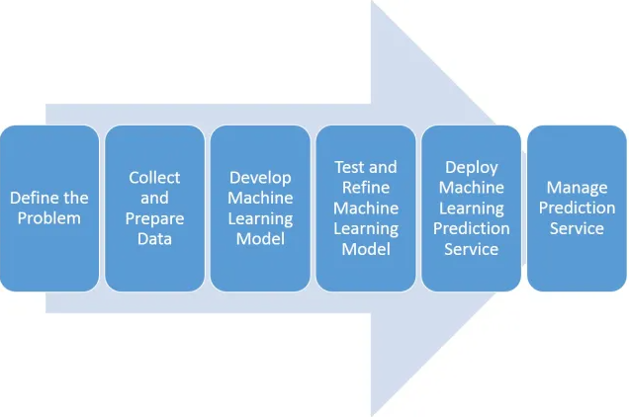

**3.2 Deployment Process**

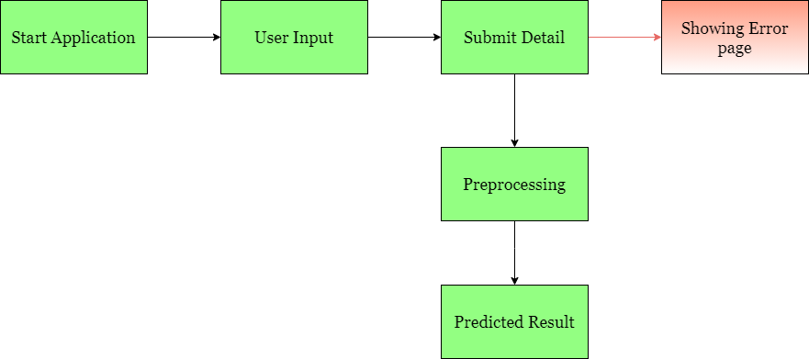

**3.3 Error Handling**

If any error occurred in the processing way then the error message should be shown to the user in a completely non-technical way that can be understandable by any person.

**4. Performance**

The Campus Placement Prediction is dependent on machine-learning algorithms. We will train various ml algorithms and will find the best fitting algorithm for predicting the target. Our system performance will be based on the data we are going to feed to the algorithms. And the performance will depend on the finalized model. model training is also very important to improve the performance.

**4.1Reusability**

The **code** written **and** the components **used** should have the **ability** to be **reused with** no **problems**.

**4.2 Application Compatibity**

The different **components for this project** will be **using** Python as an interface between **them**. Each **component will** have **its** own **task** to perform, and it **is** the job **of the** Python to ensure proper transfer of information.

**4.3 Resource Utilization**

Our application should utilize the given resource properly and it should use a minimal amount of internet to work and call the APIs on the Web page.

**5. Deployment**

The cloud environment was set up and the project was deployed from GitHub into the Streamlit cloud platform.

**6. Conclusion**

The Campus Placement Prediction is about to help Educational institutions to predict placement status for their students. It can help them to strengthen their placement department so as to improve their institution on a whole.